EXERCISE 1(Configuring a Basic Spring Application)

//BOOKREPOSITORY CLASS

package org.library;  
  
public class BookRepository {  
 public void getDetails(){  
 System.*out*.println("Book Repository is used");  
 }  
}

//BOOKSERVICE CLASS

package org.library;  
  
public class BookService{  
 private BookRepository bookRepository;  
  
 public BookService(BookRepository bookRepository) {  
 System.*out*.println("BookService Constructor is called.....");  
 this.bookRepository = bookRepository;  
 }  
  
public void display(){  
 System.*out*.println("Fetching the details form the repo.....");  
 bookRepository.getDetails();  
}  
}

//MAIN CLASS

package org.library;  
import org.springframework.context.ApplicationContext;  
import org.springframework.context.support.ClassPathXmlApplicationContext;  
  
public class Main  
{  
 public static void main( String[] args )  
 {  
 ApplicationContext context = new ClassPathXmlApplicationContext("applicationContext.xml");  
 BookService bookService=(BookService) context.getBean("bs1");  
  
 bookService.display();  
 }  
}

//APPLICATIONCONTEXT.XML

<?xml version="1.0" encoding="UTF-8"?>  
<beans xmlns="http://www.springframework.org/schema/beans"  
 xmlns:xsi="http://www.w3.org/2001/XMLSchema-instance"  
 xsi:schemaLocation="  
 http://www.springframework.org/schema/beans http://www.springframework.org/schema/beans/spring-beans.xsd">  
<bean id="bs1" class="org.library.BookService">  
 <constructor-arg ref="br1"/>  
  
</bean>  
 <bean id="br1" class="org.library.BookRepository"></bean>  
  
</beans>

//OUTPUT

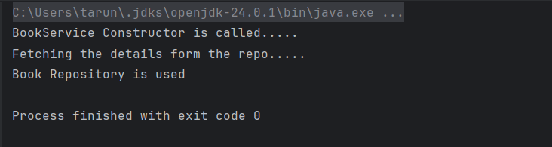

EXERCISE 2(Implementing Dependency Injection)

//BOOKSERVICE CLASS

package org.library;  
  
public class BookService {  
 private BookRepository bookRepository;  
 public BookRepository getBookRepiository() {  
 return bookRepository;  
 }  
  
 public void setBookRepository(BookRepository bookRepository) {  
 this.bookRepository = bookRepository;  
 }  
 public void display(){  
 System.*out*.println("Fetching the details form the repo.....");  
 bookRepository.getDetails();  
 }  
  
}

//BOOKREPOSITORY CLASS

package org.library;  
  
public class BookRepository {  
 public void getDetails(){  
 System.*out*.println("Book Repository is used");  
 }  
}

//MAIN CLASS

package org.library;  
import org.springframework.context.ApplicationContext;  
import org.springframework.context.support.ClassPathXmlApplicationContext;  
  
public class Main  
{  
 public static void main( String[] args )  
 {  
 ApplicationContext context = new ClassPathXmlApplicationContext("applicationContext.xml");  
 BookService bookService=(BookService) context.getBean("bs1");  
  
 bookService.display();  
 }  
}

//APPLICATIONCONTEXT.XML

<?xml version="1.0" encoding="UTF-8"?>  
<beans xmlns="http://www.springframework.org/schema/beans"  
 xmlns:xsi="http://www.w3.org/2001/XMLSchema-instance"  
 xsi:schemaLocation="  
 http://www.springframework.org/schema/beans http://www.springframework.org/schema/beans/spring-beans.xsd">  
<bean id="bs1" class="org.library.BookService">  
 <property name="bookRepository" ref="br1"/>  
  
</bean>  
 <bean id="br1" class="org.library.BookRepository"></bean>  
  
</beans>

//OUTPUT

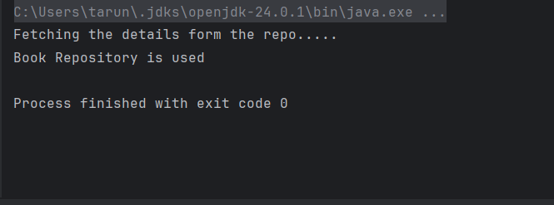

EXCERCISE 4(Creating and Configuring a Maven Project)

POM.XML

<project xmlns="http://maven.apache.org/POM/4.0.0" xmlns:xsi="http://www.w3.org/2001/XMLSchema-instance"  
 xsi:schemaLocation="http://maven.apache.org/POM/4.0.0 http://maven.apache.org/xsd/maven-4.0.0.xsd">  
 <modelVersion>4.0.0</modelVersion>  
  
 <groupId>org.example</groupId>  
 <artifactId>untitled</artifactId>  
 <version>1.0-SNAPSHOT</version>  
 <packaging>jar</packaging>  
  
 <name>untitled</name>  
 <url>http://maven.apache.org</url>  
  
 <properties>  
 <project.build.sourceEncoding>UTF-8</project.build.sourceEncoding>  
 </properties>  
  
 <dependencies>  
 <dependency>  
 <groupId>junit</groupId>  
 <artifactId>junit</artifactId>  
 <version>3.8.1</version>  
 <scope>test</scope>  
 </dependency>  
 <!-- https://mvnrepository.com/artifact/org.springframework/spring-context -->  
 <!-- https://mvnrepository.com/artifact/org.springframework/spring-context -->  
 <dependency>  
 <groupId>org.springframework</groupId>  
 <artifactId>spring-context</artifactId>  
 <version>6.2.7</version>  
 </dependency>  
 <!-- https://mvnrepository.com/artifact/org.springframework/spring-aop -->  
 <dependency>  
 <groupId>org.springframework</groupId>  
 <artifactId>spring-aop</artifactId>  
 <version>6.2.7</version>  
 </dependency>  
 <!-- https://mvnrepository.com/artifact/org.springframework/spring-webmvc -->  
 <dependency>  
 <groupId>org.springframework</groupId>  
 <artifactId>spring-webmvc</artifactId>  
 <version>6.2.7</version>  
 </dependency>  
 <!-- https://mvnrepository.com/artifact/org.apache.maven.plugins/maven-compiler-plugin -->  
 <dependency>  
 <groupId>org.apache.maven.plugins</groupId>  
 <artifactId>maven-compiler-plugin</artifactId>  
 <version>3.8.1</version>  
 </dependency>  
  
 </dependencies>  
</project>